

**Cruz-Rabe Maternity &**

**General Hospital Pharmaceutical Management System**

Introduction:

This document provides an overview of functional test cases for the Cruz_Rabe Maternity and General Hospital project use cases.

**Login:**

1.1 Purpose:

This document enumerates test cases for each of the flows described in the Use Case Specification:

Login Authentication:

1.2 Scope:

The test cases described in this document cover all techniques by which a valid CRPMS Login user account can successfully directed to the home page.

* 1. Definitions, Acronyms and Abbreviations

1.3.1 Definitions:

1. Use Case Diagram - a software and system engineering term that describes how a user uses a system to accomplish a particular goal. A use case acts as a software modeling technique that defines the features to be implemented and the resolution of any errors that may be encountered.
2. Test Case - is a set of conditions under which a tester will determine whether an application, software system or one of its features is working as it was originally established for it to do.
3. Entity Relational Diagram - is a data model for describing the data or information aspects of a business domain or its process requirements, in an abstract way that lends itself to ultimately being implemented in a database such as a relational database. The main components of ER models are entities (things) and the relationships that can exist among them.
4. Work Breakdown Structure – is a deliverable-oriented decomposition of a project into smaller components. A work breakdown structure element may be a product, data, service, or any combination thereof, A WBS also provides the necessary framework for detailed cost estimating and control along with providing guidance for schedule development and control.
5. Local Web Server - is an information technology that processes requests via HTTP, the basic network protocol used to distribute information on the World Wide Web. The term can refer either to the entire computer system, an appliance, or specifically to the software that accepts and supervises the HTTP requests.

1.3.2 Acronyms:

**The following alphabetical contraction within the text appears of this standard:**

* CRPMS-PMS - Cruz-Rabe Maternity & General Hospital Pharmaceutical Management System
* UC – Use Case
* TC – Test Case
* WBS – Work Breakdown Structure
* ERD – Entity Relational Diagram
* LS – Local Server

1.4 References

• Use Case Specification: Checkout

• Cruz-Rabe Maternity and General Hospital Test Plan

* 1. Overview
* The main goal of the project is to provide a good quality of a system that will help mainly the Pharmacist at the hospital to automate the paper work that will help them to provide a good quality and quick service to each patient.

Test Cases:

In each of these test cases, the results are verified by visual inspection.

1.6 Test Case Group 1: User Interface:

|  |  |  |  |
| --- | --- | --- | --- |
| Test ID | Test Description | Expected result | Result |
| Login_01.1 | Validate of the administrator can login successfully using admin as username and admin1 as password | Admin must be directed to the home page once the login authentication is successful |  |
| Login_01.2 | Validate if the requester can login successfully using the given user account | Requester must be redirected to the Home Page once the login was successful |  |

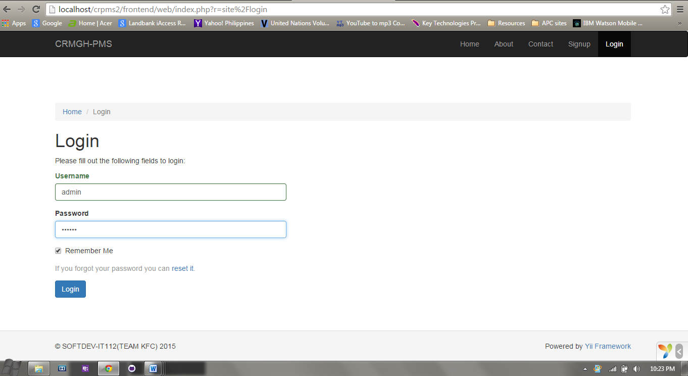Login_01.1

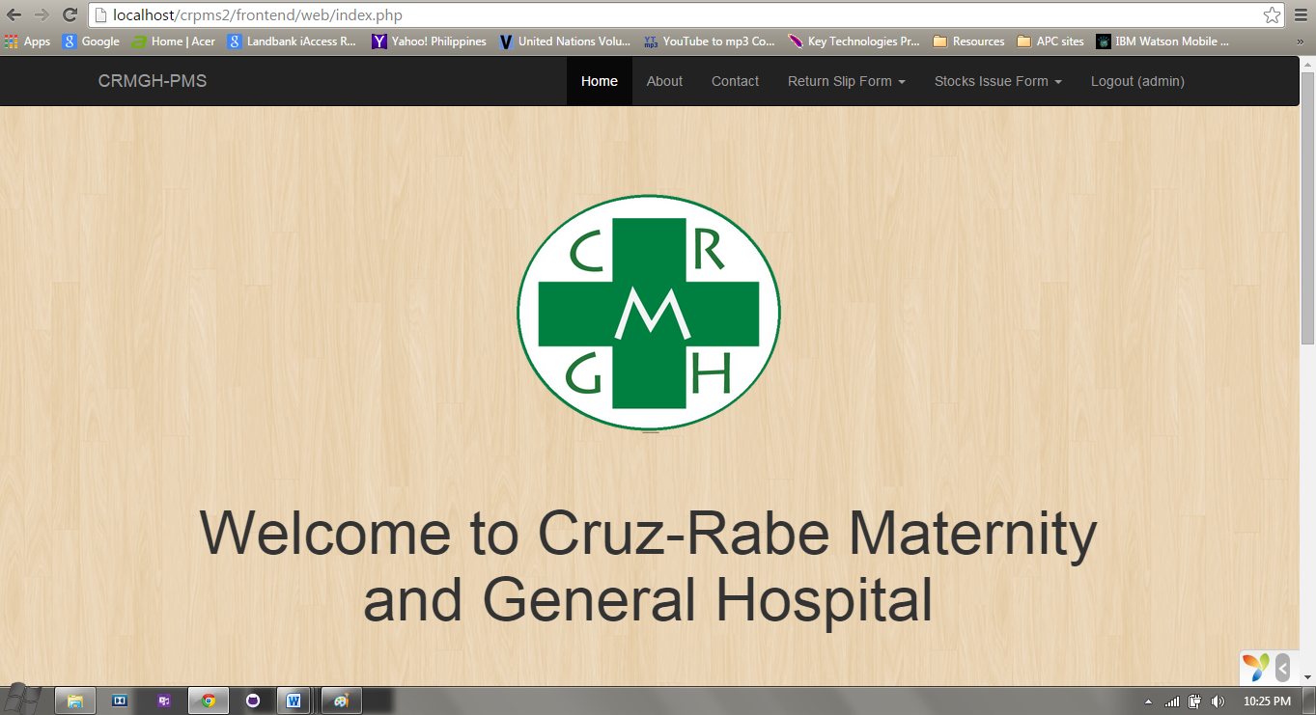Login_01.2

|  |  |  |  |
| --- | --- | --- | --- |
| Test ID | Test Description | Expected result | Result |
| Home_page_01.1 | If the user admin logged in backend/web/index.php, he/she will be redirected to Home Page and with:   * About * Contact * Stock Record * Return Slip Form * Stock Issue Form | Home Page must consist of the following dropdown list panels:   1. User – Views User entries 2. Stock Record - View Stock Record entries 3. Return Slip Form - View Return Slip Form entries 4. Stock Issue Form –View Stock Issue Form entries 5. Logout |  |

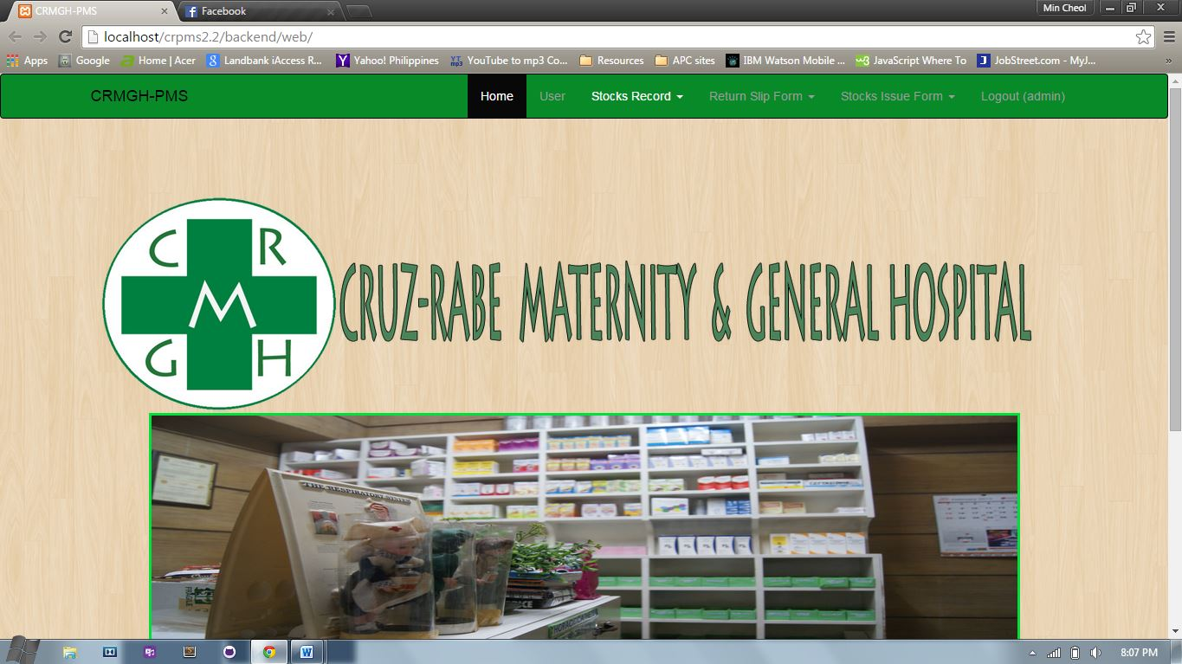Home_page_01.1

|  |  |  |  |
| --- | --- | --- | --- |
| Test ID | Test Description | Expected result | Result |
| Stocks Record_01.1 | If the user admin logged in, and the user clicked the Stocks Record tab he/she will be redirected to the stocks record index page.   * Stock Record Index * Return Item * About Medicine | Stocks Record Tab consist of the following panels:   1. Stock Record – Create stock record entries. 2. Stock Record Item – Displays the all the stocks of medicines, equipment and supplies in the pharmacy. 3. About Medicine – displays the history and description of all the medicine that are available in the Pharmacy |  |

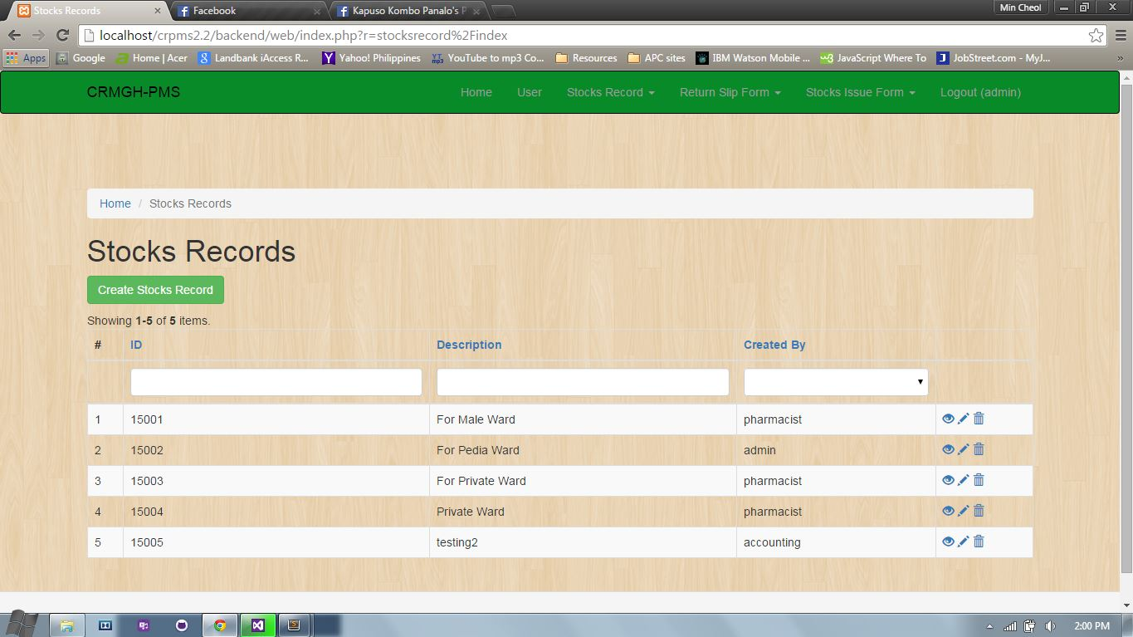Stock Record_01.1

|  |  |  |  |
| --- | --- | --- | --- |
| Test ID | Test Description | | Expected result |
| Stock_Record_Item_01.1 | If the user admin logged in, and hover to the Stocks Record Tab then clicked the Stocks Record Item. he/she will be redirected to the index view of the table:   * Stock Record Item * id * Medicine name * Available quantity * Released quantity * Delivery date | Stocks Record Item consists of the following grid view panels:   1. Id – this will stands as the identifier of each item 2. Medicine name – this identifies the name of each medicine in the list of the pharmacy. 3. Available quantity – this identifies the stock of medicines. 4. Released quantity – identifies if how many medicines were been already requested/issued to the wards. 5. Delivery date - identifies |  |

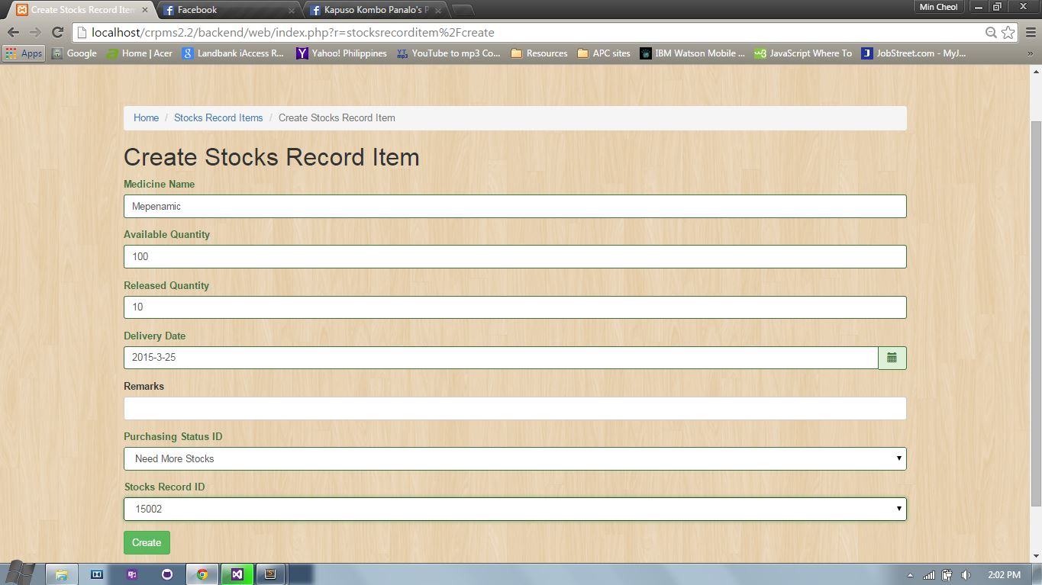Stock_record_item_01.1 (create)

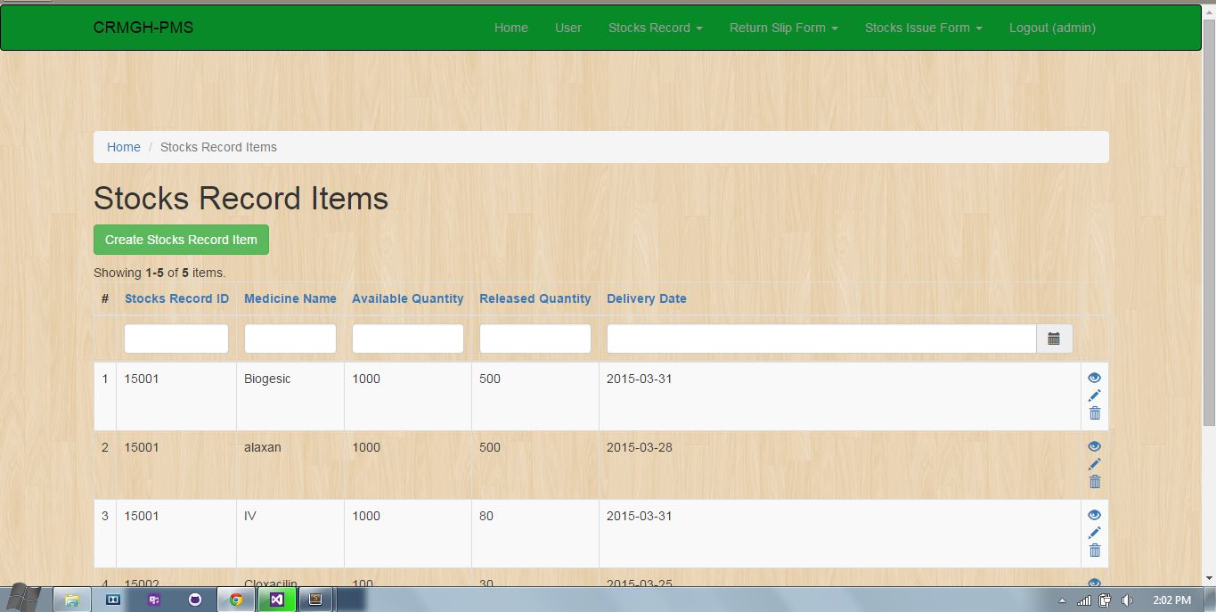Stock_record_item_01.1 (view)

|  |  |  |  |
| --- | --- | --- | --- |
| Test ID | Test Description | | Expected result |
| Stock_Issue_Form_01.1 | If the user logs in, and hover to the Stocks Issue Form Tab then clicked the Stock Issue Form. he/she will be redirected to the index view of the table:   * Date * Ward Name * Prepared by * Approved by * Issued by * Received by * User ID | Stocks Issue Form consists of the following grid view panels:   1. Date – Identifies the date when the requested medicine or medical supply will be used. 2. Ward Name – Identifies the ward where the requested medicine or supply will be issued to. 3. Prepared by – Identifies whether who prepared the requested item 4. Approved by – Identifies who approved the request form 5. Issued by – Identifies who released and issued the item 6. Received by – determines who received the requested item. 7. User ID – identifies whether who is the user that accessed the system. |  |

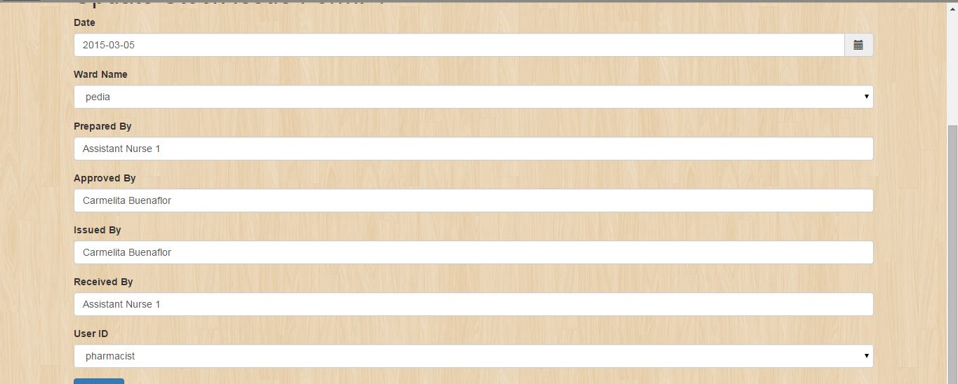Stock Issue Form_01.1 (create)

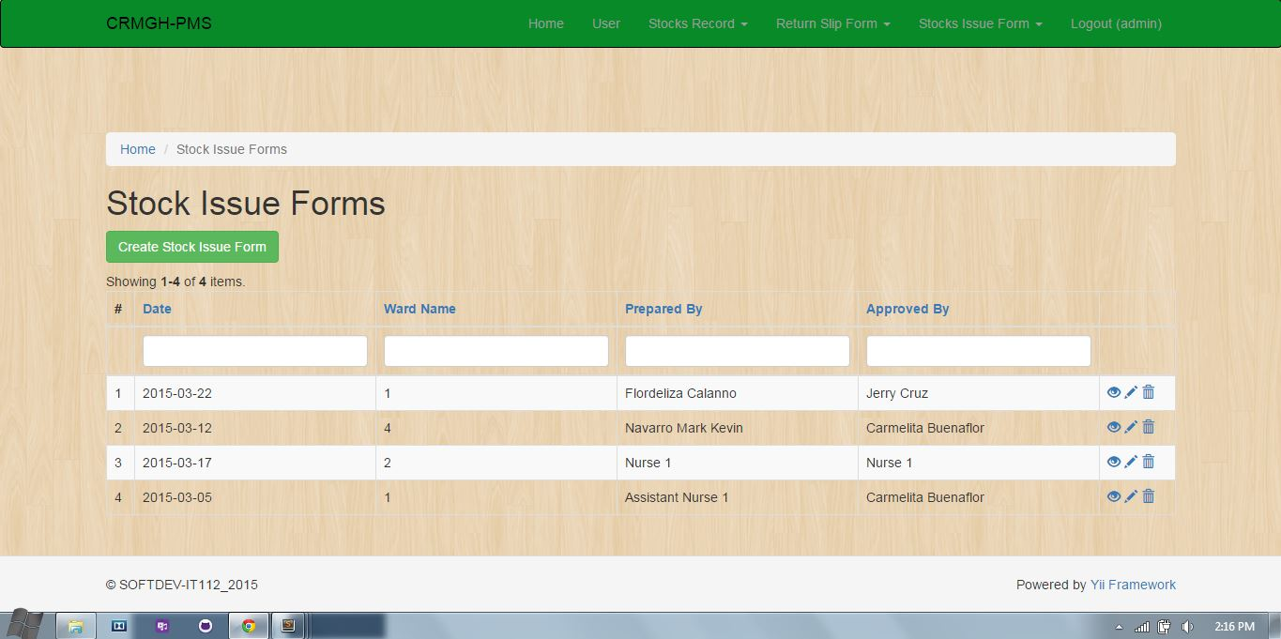Stock Issue Form_01.1 (view)

|  |  |  |  |
| --- | --- | --- | --- |
| Test ID | Test Description | | Expected result |
| Return_Slip_Form_01.1 | If the user logs in, and hover to the Return Slip Form Tab then clicked Return Slip Form. he/she will be redirected to the index view of the table:   * Return Item * id * Patient Last name * Patient First name * Patient Middle Initial * Date Admitted | Return Slip Form consists of the following grid view panels:   1. Return Item – sub entity of return slip form table. 2. Patient Last name 3. Patient First name 4. Patient Middle Initial 5. Date Admitted |  |

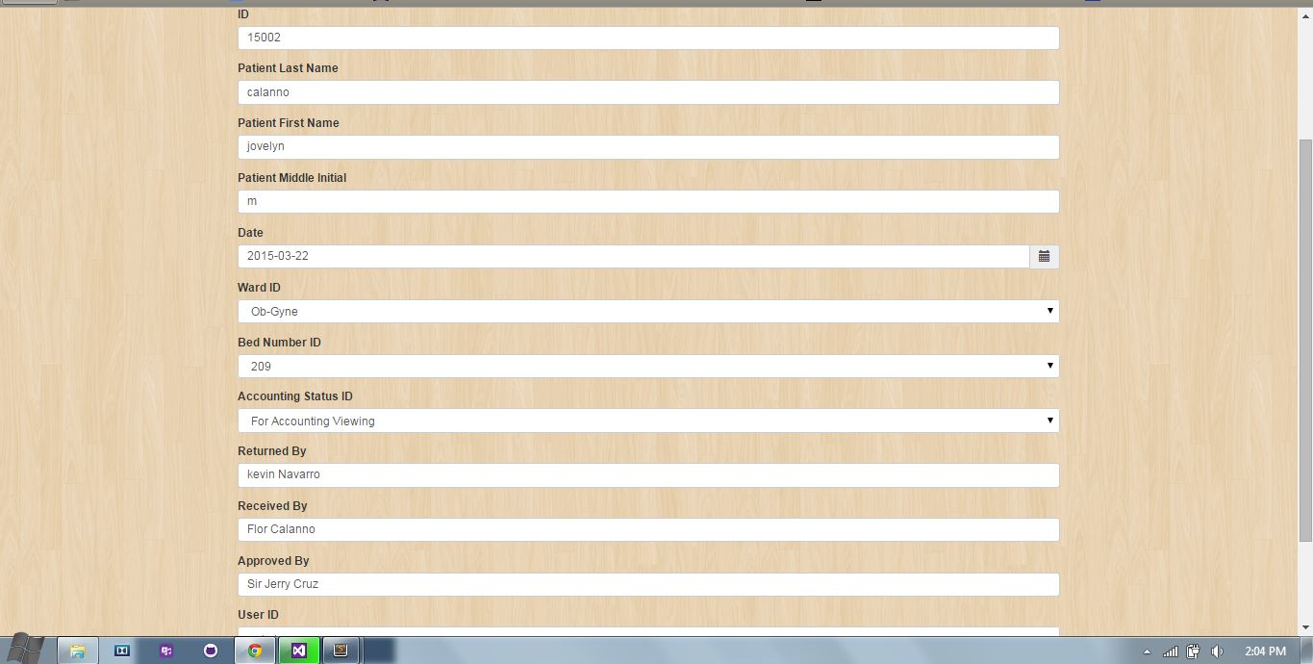Return Slip Form_01.1 (create)

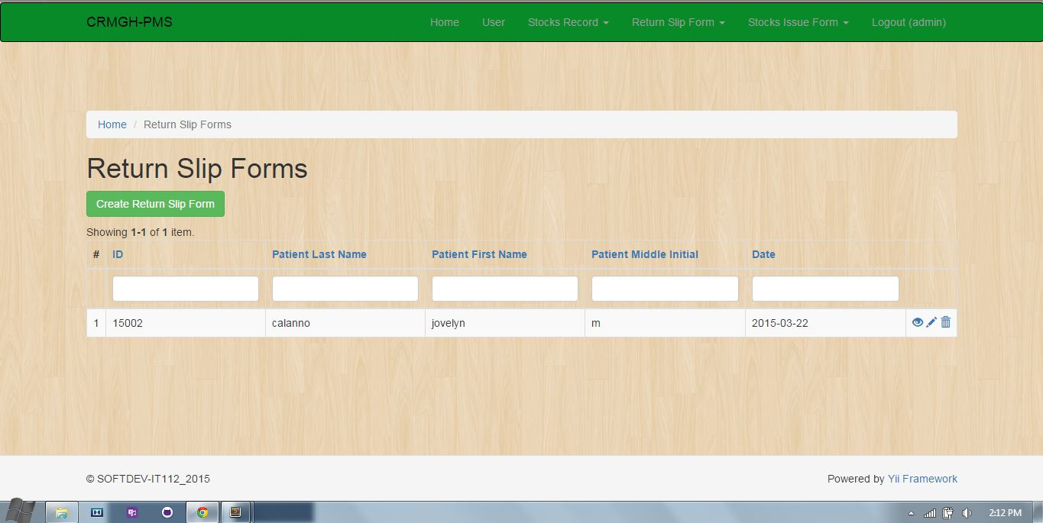Return Slip Form_01.1.1 (view)